PLANT CELL WALL
BY YOGESHWARI TIWARI
DEPARTMENT OF BIOTECHNOLOGY
GOVT.DIGVIJAY AUTO. P.G. COLLEGE RAJNANDGAON

Introduction:
The outermost rigid protective layer found in all plant cells, bacteria, cyanobacteria, and some protists is called the cell wall.
The external limit of a plant cell, which protects the cytoplasm and cell membrane.
thick, strong, non-elastic, and permeable to water, minerals, and gases.
mostly made up of cellulose little amount of hemicellulose pectic material.
lipids, minerals, and wax may also be found as structural constituents of the cell wall.

Components:
Cellulose - 10 -15%
hemicellulose - 5 -15%
water - 60%
protein - 1 -2%
lipid - 0.5%
pectic substances - 2 – 8 percent.
Structure:
the plant cell wall seems to be made up of the following layers:
Middle lamella
primary cell wall
secondary cell wall
Middle lamella - it is the cementing substance between two adjacent cells.
thin binding layer between the cells.
chemically made up of calcium and magnesium pectate.
A small amount of protein may also be found in the first layer formed during cell division
Primary cell wall –
It is formed after the middle lamella, outer thin layer, elastic, and living cell is present in meristematic and permanent cells found just inside the middle lamella, and is definitely part of two adjacent cells.
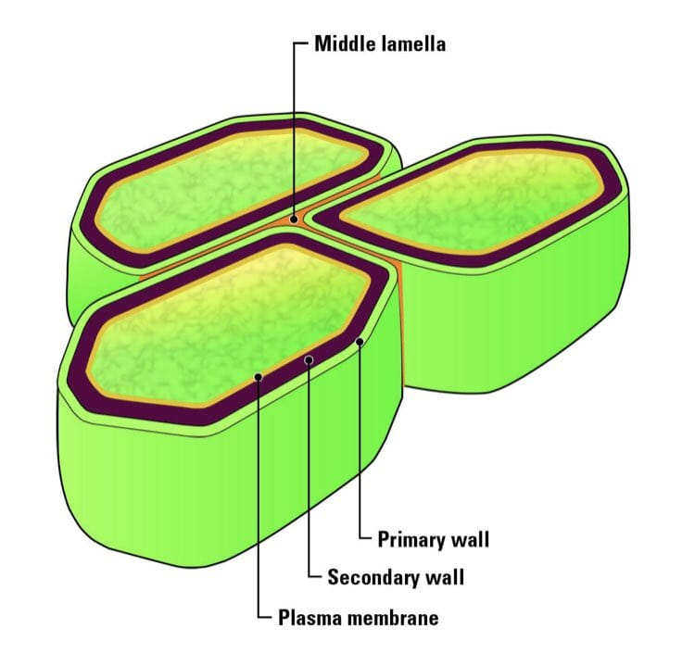
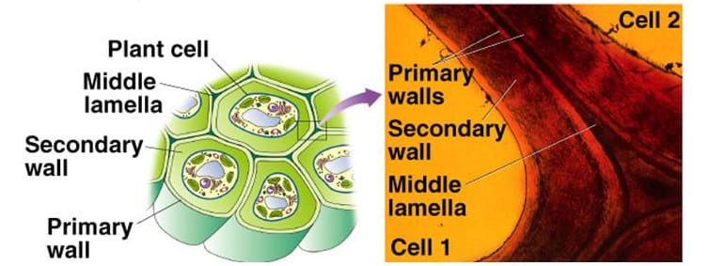

Secondary cell wall –
is formed over the primary cell wall due to secretion from the cytoplasm when growth and division of the cell cease.
referred to as the secondary cell wall.
Primarily, it is made up of cellulose and hemicellulose, but further deposition of lignin, suberin, and actin may take place in the secondary cell wall of some cells.
Deposition takes place in cork cells, lignin deposition in tracheid vessels, and cells
Tertiary cell wall –
The tertiary cell wall is deposited in a few cells.
it is considered to be the dry residue of a protoplast.
besides cellulose and hemicellulose, Xylem is also present.
chemically formed of cellulose and xylem, which gives additional strength to the cell wall.
Pits –
In xylem tracheids and vessels, the deposition of secondary cell wall is not uniform and is absent its certain places.
Pits or pore-like structures are found in the Cell wall.
pits of adjacent cell walls are deposited to each other, and form a pit canal.
such opposite pits are separated by a pit membrane.
Pit membrane is permeable and provides Rapid translocation between adjacent cells.
Plasmodesmata –
cytoplasmic strands or connections between two adjacent cells.
form the intracellular junction between them and pass through those areas where secondary wall is absent.
help in the exchange of materials between cells

